
MATHEMATICS SPECIALIST 3CD

SEMESTER 1 2010

TEST 1

Calculator Free

Reading Time: 5 minutes
Working Time: 70 minutes Total Marks: 51

1. [1, 2, 3 marks]

Spaceman Spiff takes off from home base, coordinates (0, 0, 0) and two minutes later is at position (6, 3, 2) km. His radio tells him that an ugly Xgrty beast has been sighted by two spotter craft, Alpha at A(14, 7, 3) km and Beta at B(26, 34, 9) km and such that 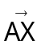: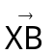 = 2:1.

(a) How far did Spaceman Spiff fly in the first two minutes?

(b) Determine the coordinates of the ugly Xgrty beast from home base.

Spaceman Spiff then alters his velocity to a vector of (3, 4, 1) km/min.

(c) Through what angle did Spaceman Spiff’s velocity change? Give your answer as an exact trigonometric function.

2. [2, 3 marks]

(a) Evaluate, showing your working, the exact value of 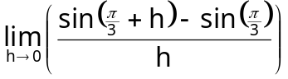

(b) Prove algebraically the limit 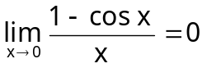

3. [2, 3, 3 marks]

(a) Given that y = 2sin θ cos θ, determine 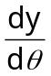

(b) Determine 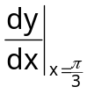 given that y = 5cos³ 2x

(c) Determine the equation of the tangent to the curve y = 3tan x at 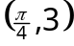.

4. [1, 2 marks]

a, b, and c are vectors such that a = 3i + 5j – 4k, b = 6i – 2j + 2k, and c = 5i + j + 5k.

(a) Show that a and b are perpendicular.

(b) Vectors a and c are also perpendicular, yet vectors b and c are not parallel. Explain (with the aid of diagrams if needed) how this can occur.

5. [3, 3 marks]

Sketch the set of points z, in the complex plane, that satisfy the following regions:

(a) |z – 3i| = |z – 3| (b) {z:|z – 3i| ≤ 3} ∩ {z:|z – 3| ≤ 3}
-3
3
3
-3
-6
6
6
-6

6. [2, 1, 2, 2, 3 marks]

(a) Determine the exact distance between the points A[3, ] and B[4, ].

(b) Calculate the point(s) of intersection of the curves r = 3 and θ = 4, for r ≥ 0 and 0 ≤ θ ≤ 2π. Give your answer in exact polar form.

(c) Calculate the point(s) of intersection of the curves r = 2θ and r = 7, for r ≥ 0 and 0 ≤ θ ≤ 2π. Give your answer in exact polar form.

(d) Calculate the point(s) of intersection of the curves {r: r = – θ , 0 ≤ θ ≤ 2π} and {θ: θ = 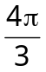, r ≥ 0}. Give your answer in exact polar form.

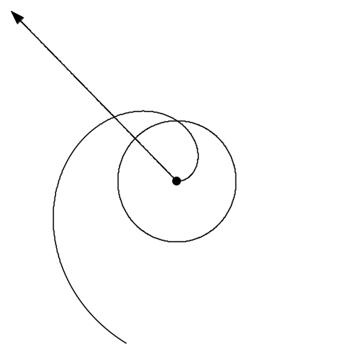
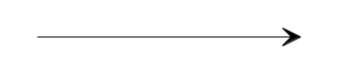

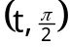

(e) The diagram below shows the polar curves r = kθ , θ = m and r = t (where k, m and t are constants).

If point P has polar coordinates 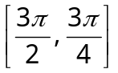, determine, exactly, the values of k, m and t.

7. [1, 5, 1, 1, 1 marks]

(a) If z = cis 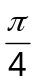 and w = cis 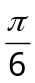
= 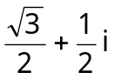

(i) Express 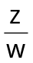 in polar form.

(ii) Express z and in Cartesian form and give with a rationalised denominator.

(iii) Use the results above to give the exact value for sin 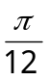

(b) If z = 3 cis and w = 2 cis 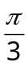, express the following in polar form

(i) iw

(ii) 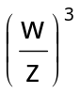

8. [4 marks]

Solve the following equation in polar form:

z⁶ + 64 = 0 where z = r cis θ with r ≥ 0, -π < θ ≤ π

